Assignment 4

- Add validations for the form for all the fields.
  - Not null
  - Min length
  - Max length
  - Fields with alphanumeric should not accept special characters.
- Submit button should be disabled until all validations on the fields are passed.
- Use regex to validate phone number, email and zip code.
- Validation should show a red color text along with each field and disappear on correcting particular field.
- Validation should be on the key events NOT at the end when submit button is pressed.
- Create a single select list box which has 5 elements.
- Write an onChange event for the created list which adds checkbox that changes dynamically for each selection.
- Example:
- 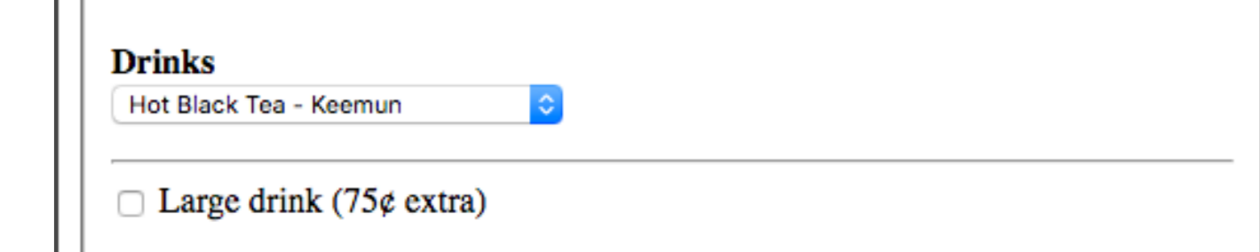
- If the checkbox is enabled, add a text field and make it mandatory and on disabling checkbox, text field should disappear.
- On submit, create a html table which takes all the data from the previously submitted form and display results.
- On submit, make sure all the form fields get cleared out
- Add validation for email address (restrict the domain to @northeastern.edu)
- Street address 2 is not a mandatory field, on submit click if the field is blank then its value in the table should be blank as well.
- Assignment must be submitted on your PRIVATE GitHub account (use Northeastern email account) and zip file must be submitted on CANVAS and GitHub URL of assignment in the canvas remarks.

